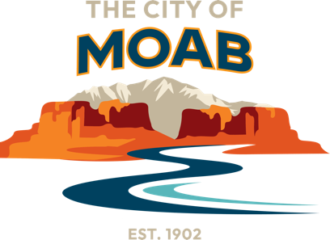

Organization: City of Moab

Position Title: City Manager

Address: 217 East Center Street, Moab, UT 84532

First Review: June 30, 2024

Salary: $175,007 to $262,510 annually DOQ

The City of Moab is seeking a City Manager to join this vibrant community of 5,500 located along the Colorado River in rugged southeastern Utah. The region is known for its stunning red rock cliffs and towering sandstone formations, attracting 3 million global visitors a year.

Moab is home to a diverse mix of residents who enjoy a laidback lifestyle with easy access to the best of both worlds —limitless outdoor recreation as well as a thriving cultural scene. Moab's quaint downtown is home to locally owned shops, art galleries, eclectic restaurants, outfitters, and a park dedicated entirely to food trucks. In 2022, Utah State University Moab opened its doors to students with a new 4-year campus just south of town.

THE CITY OF MOAB

Incorporated in 1902, the City of Moab operates under a Council-Manager form of government. The City serves an approximate permanent population of 5,500 with an estimated variable population of 20,000-30,000 during the tourist season with a 2023 budget of $24 million and a team of 157 FTEs. Administration includes the City Manager, Finance Director/COO, and Executive Administrative Assistant.

WHY APPLY

This is an excellent opportunity to bring your passion for public service and make a positive impact at the dynamic and future-focused City of Moab in the heart of the Colorado Plateau. The new City Manager will come into a very stable organization that benefits from a vibrant community spirit among residents and a strong core of City staff who are mission-oriented and driven. Moab is in a high-profile part of the state and country and the City culture benefits from its small-town atmosphere. Come work with great people and enjoy a work-life balance in a world-renowned outdoor destination that attracts over 3 million people a year.

View the full position profile and job description at [gmphr.com](https://gmphr.applicantstack.com/x/detail/a2nm8xmq7rpu/aa0).

**More Information:** GMP Consultants is assisting the City of Moab with this search. Learn more at [gmphr.com.](http://gmphr.com) The City of Moab is an Equal Opportunity Employer. First Review is June 30, 2024.